the 6th Annual
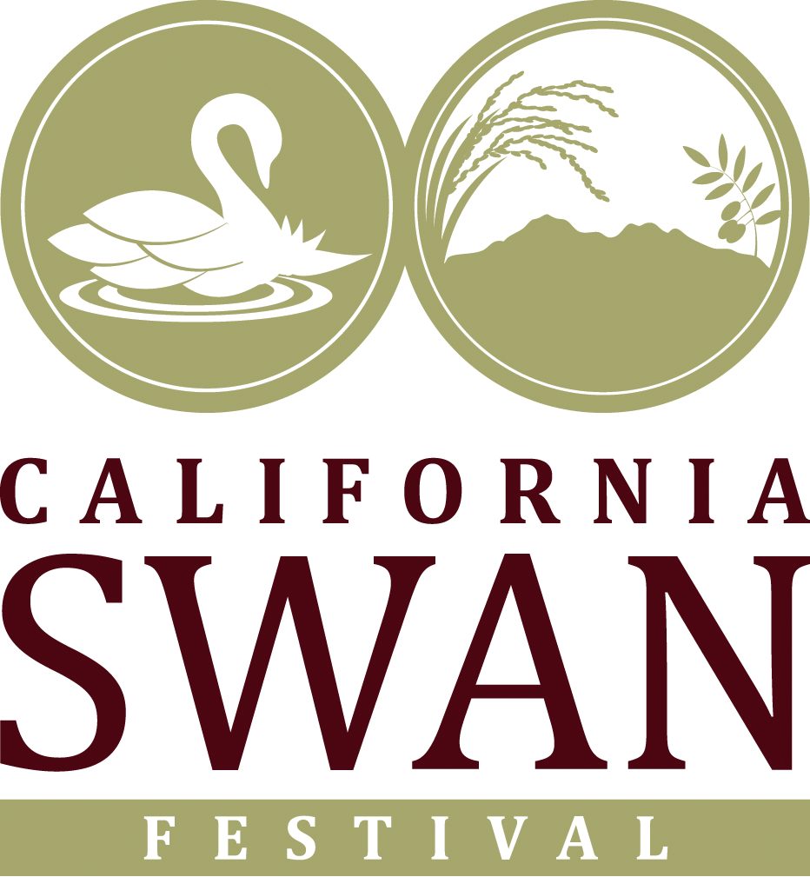

Swan Festival
2024
Vendor and Exhibitor Application
Yuba College 2088 N Beale Ave, Building 300, Marysville, CA 95961
Saturday & Sunday, November 9 & 10, 2024

Dear Vendor/Exhibitor,

Returning vendors and exhibitors, thank you for your previous support and participation in the California Swan Festival. For new participants, welcome! We are preparing for this year’s event and each year we work to improve upon the year before. We would like to receive your commitments as early as possible to include your participation in all marketing materials.

Within the Vendor / Exhibitor application you will find detailed instructions regarding the information necessary to ensure a well planned and organized event for vendors and participants alike. Please fill it out completely and return it as soon as possible. Thank you again and we look forward to seeing you at the event!

Best Regards,
Olivia Moore
Phone: 530-755-3568
info@sutterbutteslandtrust.org

2024 Swan Festival Event Guidelines

- To be eligible for a full refund, cancellations must be made in writing, and postmarked no later than September 30, 2024. Cancellations must be mailed to SBRLT, P.O. Box 3359 Yuba City, CA 95992. If Cancellations are made after September 30, 2024, no refunds will be given. No exceptions.
- All vendors are required to submit a certificate of insurance in the amount of $1 million in general liability naming SBRLT. Mail certificate to: SBRLT, P.O. Box 3359 Yuba City, CA 95992.
- The event will occur rain or shine, fees will not be returned due to inclement weather or Acts of God.
- Selection of vendors is at the discretion of management based on the vendor’s ability to enhance the overall event image – management reserves the right to refuse or assign space at any time.
- Space is allocated based on any or all the following criteria: past participation, supply and demand, application date, logistics, and presentation of product and booth appeal.
- Vendors do not have exclusivity on any one product type.
- All vendors must be open and operating during the entire duration of the event.
- Booth space assignment subject to change up to the day of the event.
- All vendor merchandise must be approved through the application process.
- Set-up and teardown: Set-up complete by Saturday, November 9 at 8:00 am, tear down no earlier than Sunday, November 10, 2:00 pm.
- All merchandise must be displayed on a table, rack, or shelving (some exceptions may apply, contact for details).
- Vendors will be provided with 1 table and 2 chairs per space, all other equipment responsibility of the vendor, unless purchased through this application.
- All vendors must supply the necessary trashcans for garbage inside their booth space. Excess garbage must be placed inside the provided event dumpsters. Vendors must adhere to all recycling guidelines.
- If repair, damage and/or cleaning costs are incurred and the event committee determines that the vendor is responsible, those costs shall be reimbursed in full to SBRLT by the vendor within 10 days of SBRLT’s written demand for such costs.
- No smoking inside the building.
- Absolutely no alcoholic beverage consumption permitted by vendors.
- In the event vendor has failed to occupy their space 30 minutes prior to event start, manager shall have the right to utilize such space in any manner it chooses; vendor shall be entitled to no refund.
- In the event that a vendor for any reason does not comply with the regulations of this event, the event manager reserves the right to close down that vendor. Said vendor will forfeit all fees paid.

--SAVE THIS PAGE FOR YOUR RECORDS--

ADDITIONAL REQUIREMENTS/INFORMATION FOR FOOD/BEVERAGE VENDORS

PRODUCE & FOOD VENDORS ONLY
- All food & beverage vendors are required to submit a certificate of insurance in the amount of $1 million in general liability naming SBRLT. Mail certificate to: SBRLT, P.O. Box 3359 Yuba City, CA 95992.
- Food vendors must provide garbage receptacles at booths.
- Food items/edible produce must be kept at least 6 inches above ground at all times.
- Produce must be in a container with labels identifying the produce and the source of the products.
- Must have documentation showing proof of ownership for each lot of produce.
- Food stamps are NOT accepted at events.
- Prices must be clearly posted on or around all produce.
- All food handlers must wear plastic gloves and appropriate hair covering per the Health Dept. guidelines.
- Vendors using grills or open flames must have the proper fire extinguisher at their space and proper waste cans. These vendors also must provide ample fans to deflect smoke.

REQUIRED PERMITS: Copies of each certificate and/or permit must be submitted with application.
Craft/Commercial Vendors:
- Seller’s Permit/Resale License – call the State Board of Equalization at 800-400-7115
- If selling pre-packaged, non-potentially hazardous or processed foods (e.g. candy, jam, baked goods, etc.) a copy of processing facilities CA State Health Cert. and Commissary form is required
Food Service - same requirements as Craft/Commercial above, plus:
- Environmental Health Dept. Permit – call Sutter County Community Services at 530-822-7400

Produce Vendors:
- California Dept. Food and Agriculture license
- If selling pre-packaged, non-potentially hazardous processed foods (e.g. flavored nuts, jams, dried fruit) must have CA State Health Cert.
Ag Department Information 530-822-7500, State Health Department information 916-323-8518

For more information on event guidelines call 530-755-3568,
or email info@sutterbutteslandtrust.org

--SAVE THIS PAGE FOR YOUR RECORDS--

2024 SWAN FESTIVAL EXHIBTOR/VENDOR APPLICATION

VENDOR or EXHIBITOR (circle one):

Type: (circle one): Commercial Food Craft/Produce Non-profit Government Agency
Other: __________________________

Group or Business Name: ________________________ Contact Name: __________________

Address: _________________________ City: _____________________ Zip: ____________

Business Phone: _______________ Cell Phone: _______________ Fax: ________________

E-mail address: _____________________________ Web Site: ________________________

Non-profit IRS # ________________

 CA Seller’s Permit/Resale License # ________________________ (Attach copy to application)

 General Liability Insurance (Attach copy to application)
Have you participated in the Swan Festival before? If yes, list event(s) and year: _____________________________________________________________________________

Description of products to be sold, promoted, displayed, or given away.. ___________________ ____________________________________________________________________________________

Will You Need Electricity? Yes / No
If yes, describe equipment that will be used: ____________________________________________________________________________________

The undersigned has read the regulations that are hereby part of this contract and by signature below agrees to adhere/abide by them. This agreement shall be construed pursuant to the laws of the state of California.

_______________________________ __________________________________ _________
Signature Print Name Date

Vendor Type | Cost Per 6’ Table | # of Tables | Total
Commercial | $75
Non-Profit or Govt. | $0
Non-Profit Concessionaries or Crafter’s (100% Homemade) | $50

For Questions or payment contact Olivia Moore, info@sutterbutteslandtrust.org or call (530) 755-3568

